**1)** A) Done, submitted to teach.

B) Done, submitted to teach. I am using the first iterative shown.

**2)** a) Recursive - I believe my project is working accordingly, and printing the correct steps

* I found that I had implemented the wrong one as recursive, I have tried to correct this, but the tower that is specified is wrong after the first four. I could not find the fix for this.

b) Iterative - I had some issues implementing the printing, the first few will print correctly, but after that it seems to be offset, and I cannot figure out why.

**3)** - See end page, drew it out on my laptop.

**4)**removed print lines, and ran. Results are in chart in next question.

**5)**

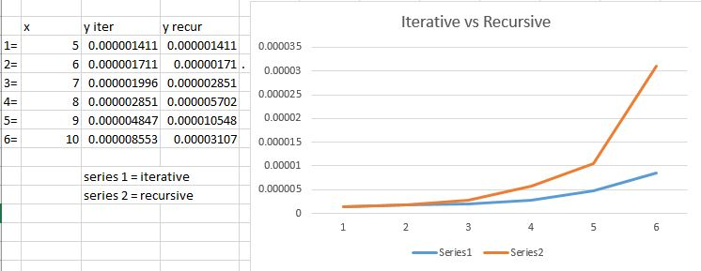

**6) C2^N figure out C**

Iterative

C * 2^10 = .000008553

C * (1024) = .000008553

C = ~ .00000000835254

Recursive

C * 2^10 = .00003107

C * (1024) = .00003107

C = ~.0000000303418

**7)** From the appearance of the chart, and the equation we had figured from the last problem, it appears that the iterative set is much more efficient for large numbers of runs.

Iterative

C * 2^64 =x

.00000000835254 * 2^64 = x

X = 1.54077 x 10^11 seconds

Recursive

C * 2^64 =x

.0000000303418 * 2^64 = x

X = 5.59707 x 10 ^ 11 seconds

**9) Can solve N in 10 min**

Iterative

c*2^n = 10*60

.00000000835254 * 2^n = (10*60)

N = ~36.064

Recursive

c*2^n = 10*60

.0000000303418 * 2^n = (10*60)

N = ~34.2029

